EVOLUTION GAME WORKSHEET

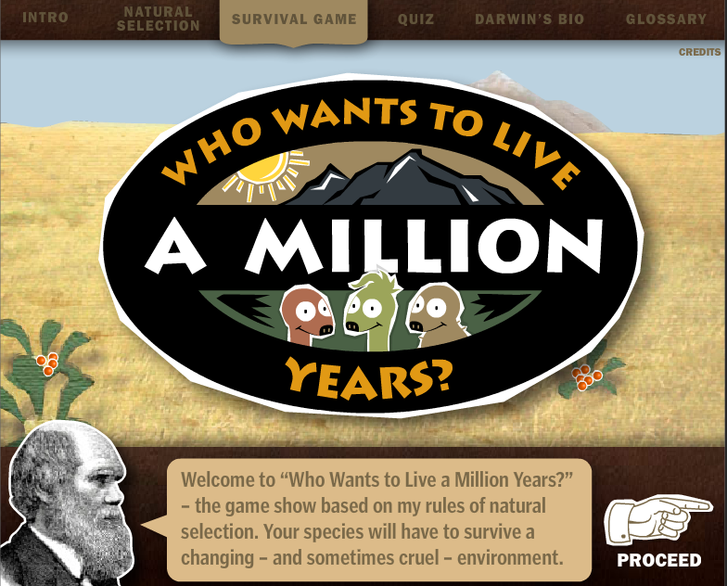

The objective of this game is to create species that will survive and thrive over many generations, even as climate and environmental change occur.

INSTRUCTIONS:
- Go to the website: http://www.sciencechannel.com/games-and-interactives/charles-darwin-game/
- Click on “LEARN ABOUT NATURAL SELECTION”
- Click through the slides and answer questions 1 and 2 below.
- Once you have finished, the program leads you to the GAME page. Click “PROCEED”.
- Play the game. You will pick any 3 mutations you want to populate your ecosystem. The HINT menu gives you details on the traits available! 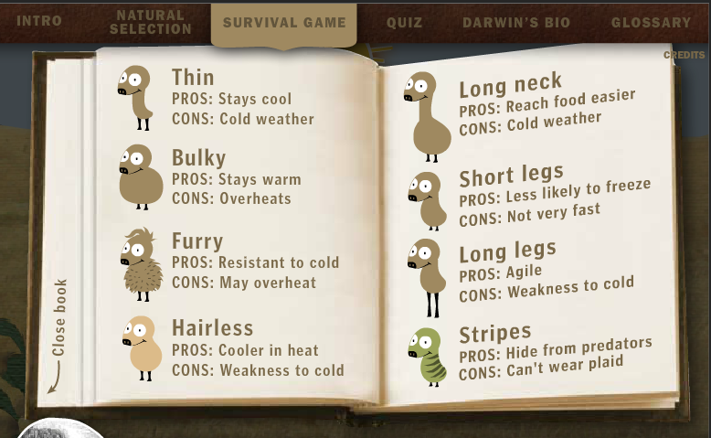
- When you encounter your first environmental obstacle, answer question 3 below.
- If you die before reaching the second environmental obstacle, start over and pick better-suited creatures. You also have 2 life-preservers. When you encounter your second environmental obstacles, answer question 4.
- If you die before reaching the third environmental obstacle, start over and pick better-suited creatures. You also have 2 life-preservers. When you encounter your second environmental obstacles, answer question 5.
- Now go to the QUIZ section. Take the quiz and write your answers in the QUESTIONS section below.

Questions:
- What are some examples of “variations” among a species?

- What is “survival of the fittest?”

- What was the first environmental obstacle your ecosystem encountered? What mutation(s) survived the change?

- What was the second environmental obstacle your ecosystem encountered? What mutation(s) survived the change?

- What was the third environmental obstacle your ecosystem encountered? What mutation(s) survived the change?

- Describe the traits if the creature that survived until the you won the game.

ANSWERS TO ONLINE QUIZ SECTION. (you may write the letter only).
1) 2) 3) 4) 5)
6) 7) 8) 9) 10)

You may repeat the ONLINE quiz until you get 100%.

What was your final QUIZ score> _____

